SESSION 15: R FOR BUSINESS ANALYTICS

Assignment 3

1. Introduction .......................................................................................................................................... 3

2. Objective ............................................................................................................................................... 3

3. Prerequisites ......................................................................................................................................... 3

4. Associated Data Files ............................................................................................................................ 3

5. Problem Statement ............................................................................................................................... 3

6. Expected Output ................................................................................................................................... 3

7. Approximate Time to Complete Task ................................................................................................... 3

**1. Introduction**

This assignment will help you understand the concepts learnt in the session.

**2. Objective**

To understand the concepts in R.

**3. Prerequisites**

Not applicable.

**4. Associated Data Files**

N/A

**5. Problem Statement**

1. Write a R program using control operators to test whether following values are prime numbers or not by providing a PRIME or NOT PRIME message as output :

1. 103 b. 82 c. 179

Solution:

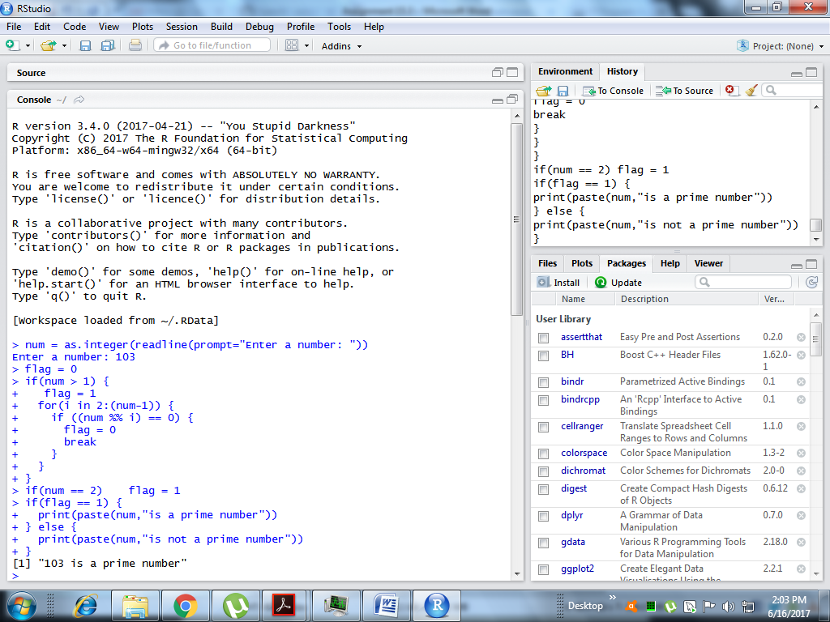

Now for 82

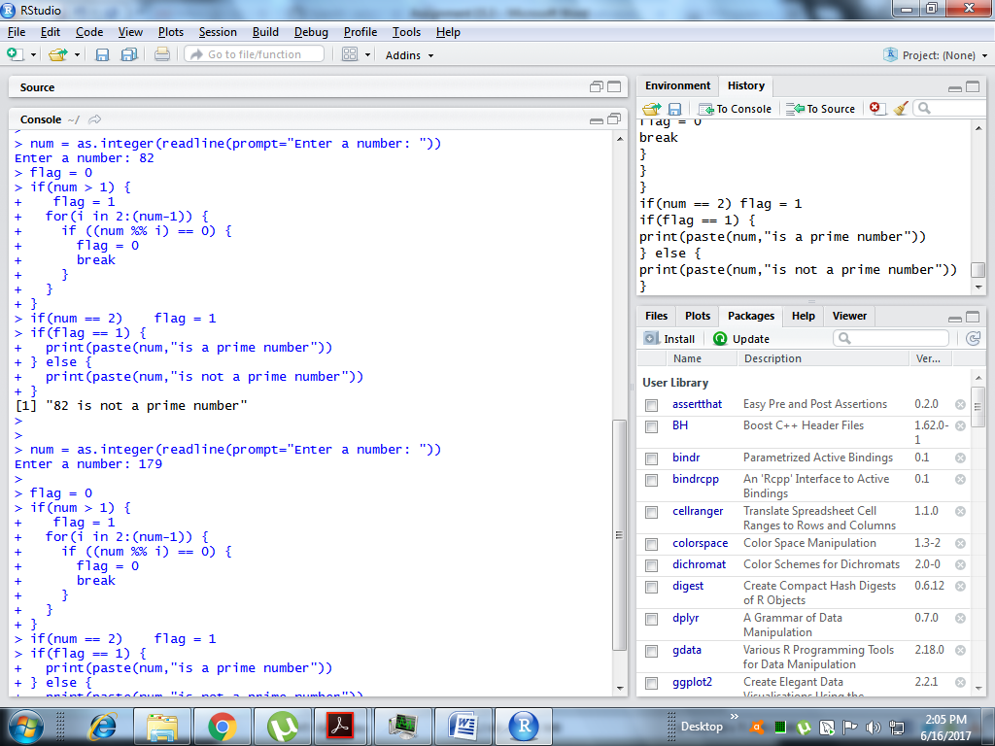

And checking number #179

